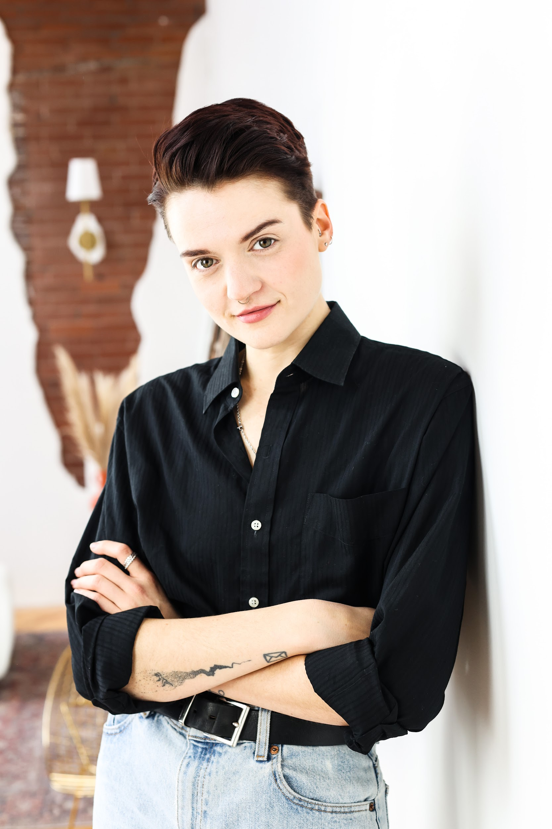
Eli Holliday
Eli Holliday (They/Them/Theirs)
Non-Union
Range: F3 - F5
hollidayeliz@gmail.com - (604) 379-3266
SELECTED THEATRE
GIN & SIN: AN IMMERSIVE MURDER MYSTERY (2024) Emcee/Junior Bar Team Theatre
Dir. Michael Manning
LADIES AND GENTLEMEN, BOYS AND GIRLS (2024)* Felix/Dad Roseneath Theatre
Dir. Andrew Lamb
*Nominated for a 2024 Dora Award for Outstanding Ensemble in Theatre for Young Audiences
[in-] (2023) Director SpaceSpace Revolution One Night Only
Dir. Ethan Persyko
TRACE (2023)* Epic Choir of Traceland ReDefineArts & Theatre Passe Muraille
Dir. Moynan King
*Nominated for a 2023 Dora Award for Outstanding Ensemble in an Independent Theatre Production

PRECIOUS LITTLE (2019) C Star Star Theatre (Vancouver, BC)
Dir. Mika Laulinen

VENUS AND MOON (2018) Venus IGNITE! Theatre Festival (Vancouver, BC)
Dir. Sophia Saugstad

WE RISE UP IN HOT AIR (2018) Bella IGNITE! Theatre Festival (Vancouver, BC)
Dir. Kimberly Ho

THE VAGINA MONOLOGUES (2014) Hair UBC V Day (Vancouver, BC)
Dir. Giselle Miller

ONE DAY IN THE LIFE OF HENRI SHNUFFLE (2013) Princess LaLa Spratt Theatre (New York, NY)
Dir. Ryan Elisabeth Reid

SELECTED DRAG PERFORMANCE
WHAT THE FESTIVAL (2024) Performer
FISHER PRIDE (2023-2024) Performer, Facilitator Thomas Fisher Rare Book Library
CATEGORY IS…? (2020-2024) Host, Performer Glad Day Bookshop, The Drink, The Gladstone
PRIDE TORONTO (2021-2024) Performer Senior, Bi+, and Trans Pride, Drag Ball, Pride Parade
STORYTELLING WITH DRAG QUEENS (2019-2023) Performer Storytelling With Drag Queens Foundation
JAYU ARTS PRIDE CABARET (2022) Performer JAYU Festival Inc.
PLAY DATE TORONTO (2021) Spotlight Performer RendezViews
STAND WITH WET’SUWET’EN (2020) Performer Buddies in Bad Times Theatre
KINGS & CLASSICS (2020) Performer Buddies in Bad Times Theatre
DRAG HEALS (2020) Performer Buddies in Bad Times Theatre
HOUSE OF KINGS (2020) Performer Glad Day Bookshop
INSIDE OUT LGBT FILM FESTIVAL (2019) Host, Performer Hot Docs Ted Rogers Cinema
MIXED MESSAGES CABARET (2019) Host, Performer Vancouver, BC
KAMLOOPS PRIDE (2019) Performer Kamloops, BC
DRAG CAMP FOR KIDS (2019) Organizer, Facilitator, Performer Vancouver, BC
MAN UP (2018-2022) Performer Vancouver, BC
COMMERCIAL DRAG (2018-2019) Performer Vancouver, BC
MISFITS (2018-2019) Performer Vancouver, BC
MASSY PRIDE (2018) Host, Performer Vancouver, BC

FILM & TELEVISION
DRAG HEALS SEASON 2 (2020) Self Border2Border Entertainment
SOMETHING IN THE WATER (2018) Partygoer Eirik Hutchinson
WHO IS GENOVESE MENDOZA (2013) Joie School of Visual Arts
COMMERCIAL & VOICEOVER
KRAFT (2019) Voiceover
XFINITY WIFI (2019) On-camera
MICHAEL HILL JEWELLERS (2019) Voiceover
FACEBOOK WATCH (2018) On-camera, Voiceover
AMEX (2018) On-camera

PRODUCTION
FISHER PRIDE (2024) Thomas Fisher Rare Book Library
CATEGORY IS…? (2020-2024) Glad Day, The Drink, The Gladstone, Three Dollar Bill
MIXED MESSAGES CABARET (2019) Vancouver, BC
DRAG CAMP FOR KIDS (2019) Vancouver, BC
MASSY PRIDE (2018) Vancouver, BC
THE VAGINA MONOLOGUES (2014) - Dir. Giselle Miller Vancouver, BC

PUBLICATIONS
SAD MAG (2017 – 2022)
Features, reviews, and interviews with LGBTQ2+ and BIPOC art and artists working in theatre, film, music, and visual art formats.
Web Editor from 2018-2019.

ROOM MAGAZINE (2019)
Book reviews on contemporary fiction by women and LGBTQ2+ people.

LOOSE LIPS MAGAZINE (2018 – 2019)
Features, reviews, and personal essays on theatre, comedy, and performance by women and LGBTQ2 and BIPOC folx.

DISCORDER MAGAZINE (2016 – 2018)
Features and reviews on alternative music, politics, books, and LGBTQ2+ entertainment.

RESIDENCIES & AWARDS
NIGHTWOOD INNOVATORS PROGRAM (2023-2024)
Nightwood Theatre
ABSOLUT EMPIRE’S BALL, 1st RUNNERS UP - HOUSE OF FAITH (2023)
Absolute Empire’s Ball
MIRIAM BRAVERMAN MEMORIAL PRIZE, ESSAYS IN ACTIVIST LIBRARIANSHIP (2021)
Progressive Librarians Guild
PRIDE TORONTO ARTIST IN RESIDENCE, THE HOUSE ROYALE COLLECTIVE (2020-2021)
Pride Toronto

EDUCATION
MASTER OF INFORMATION - LIBRARY AND INFORMATION SCIENCES
University of Toronto, 2021

BACHELOR OF ARTS - GENDER, RACE, SEXUALITY AND SOCIAL JUSTICE
University of British Columbia, 2017

CERTIFICATE - INTEGRATED PERFORMANCE
American Musical and Dramatic Academy, 2013

TRAINING
Acting Jason Chaet, Dan Daily, Ray Virta
Musical Theatre David Caldwell, Catherine Cox, Tom Morrissey, Teri Ralston, Stacy Lee Tilton
Vocal Production and Speech Angela Eckard, Joe Goscinski, Timothy Joseph Ryan, Michelle Bruckner
Dance Casey Colgan, Ramon Galindo, James Kichler, Billy Johnstone, Cynthia Murray-Davis, KJ McKnight
Voice Kristi Kelly, Cassandra Warner

SPECIAL SKILLS
Guitar, Ukulele, Basic French, Hosting, Drag Performance, Burlesque, Boxing, Canoeing

